**EXPERIMENT - 5**

**AIM: To upload and analyse yeast glycolytic model in JWS online**

URL : <https://jjj.biochem.sun.ac.za/>

**THEORY:**

JWS Online Database: Introduction

JWS Online is a web-based platform for construction, simulation and exchange of models in standard formats. We have extended the platform with a database for curated simulation experiments that can be accessed directly via a URL, allowing one-click reproduction of published results. Users can modify the simulation experiments and export them in standard formats. The Simulation database thus lowers the bar on exploring computational models, helps users create valid simulation descriptions and improves the reproducibility of published simulation experiments.

JWS Online has been optimised and tested on the following browsers:

● Google Chrome

● Chromium

● Safari

● Opera

Certain browsers are known to produce erroneous behaviour with JWS Online in ways that

are largely outside of our control:

● Firefox:

1) SVGs are not rendered correctly

1. mouse gestures are over-interpreted

Procedure:

Locating and Loading a model:

All models stored on JWS Online are assigned a unique slug for easy identification, and all models are stored under: http://jjj.bio.vu.nl/models/. For example, the yeast glycolytic model published by Teusink et al. (Can yeast glycolysis be understood in terms of in vitro kinetics of the constituent enzymes? Testing biochemistry.) is referred to on JWS online with the simple teusink slug, and thus can be accessed directly at:http://jjj.bio.vu.nl/models/teusink

1. Click on Model Database tab.

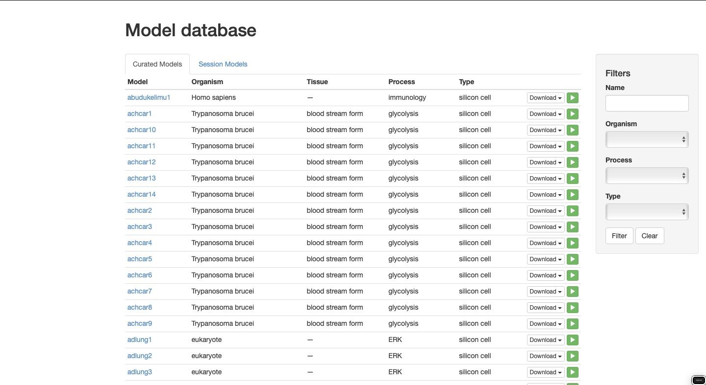

2.Type your complete query in search filter.

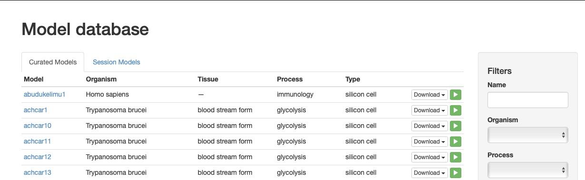

3.Each listed model has a set of action buttons. These buttons allow the model to be downloaded in SBML, Mathematica notebook, JWS, and PySCeS format respectively. The download button loads the model in the Model Simulation page. From this page all the simulation and analysis features of JWS Online can be explored.

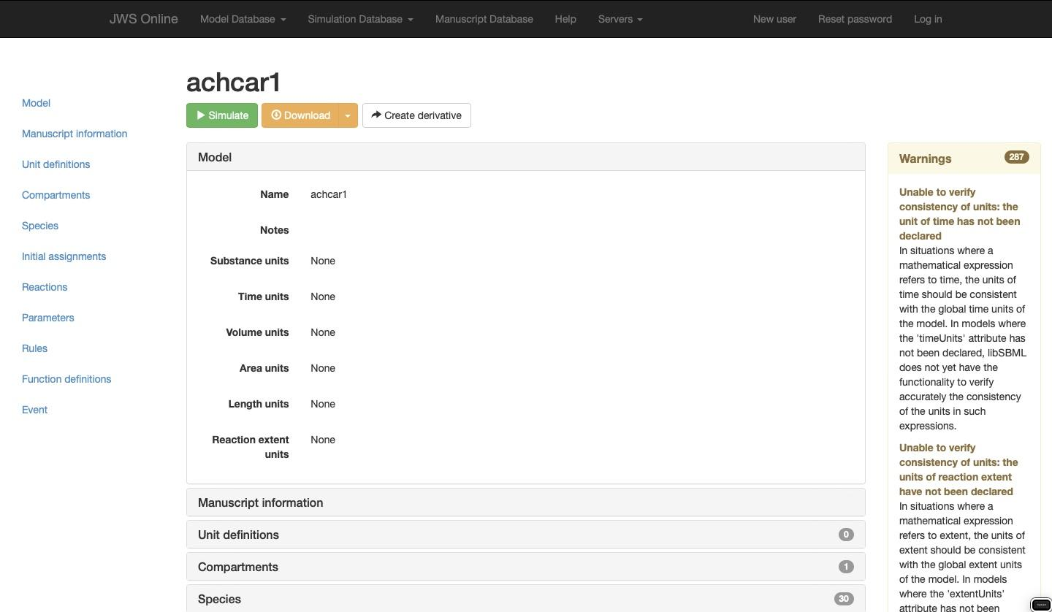

**SCHEMA:**

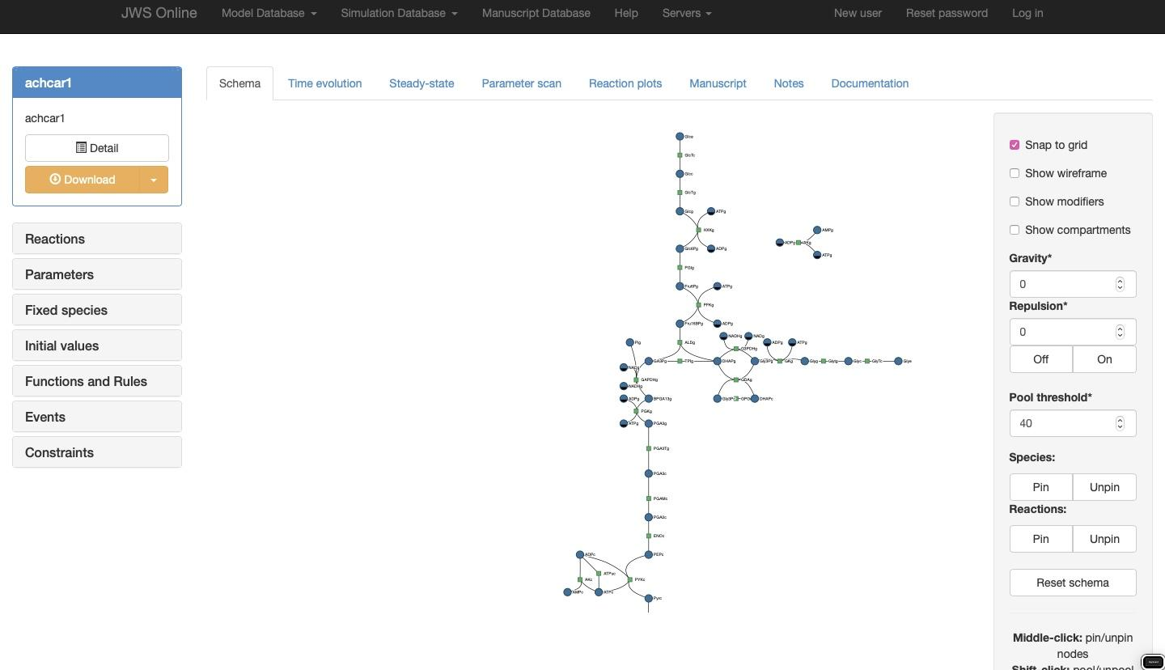

4.From this page all the simulation and analysis features of JWS Online can be explored.

The Schema: Models are represented by a dynamically-rendered schema consisting of reaction and species nodes. Certain curated models have predefined schemas which are applied upon instantiation; other models are simply layed out using a forcing function. Right-clicking on these nodes will reveal a context menu containing links to respective reaction plot pages, annotations, rate equations, species structures, and external links to query the entity in either the BRENDA or SABIO-RK databases

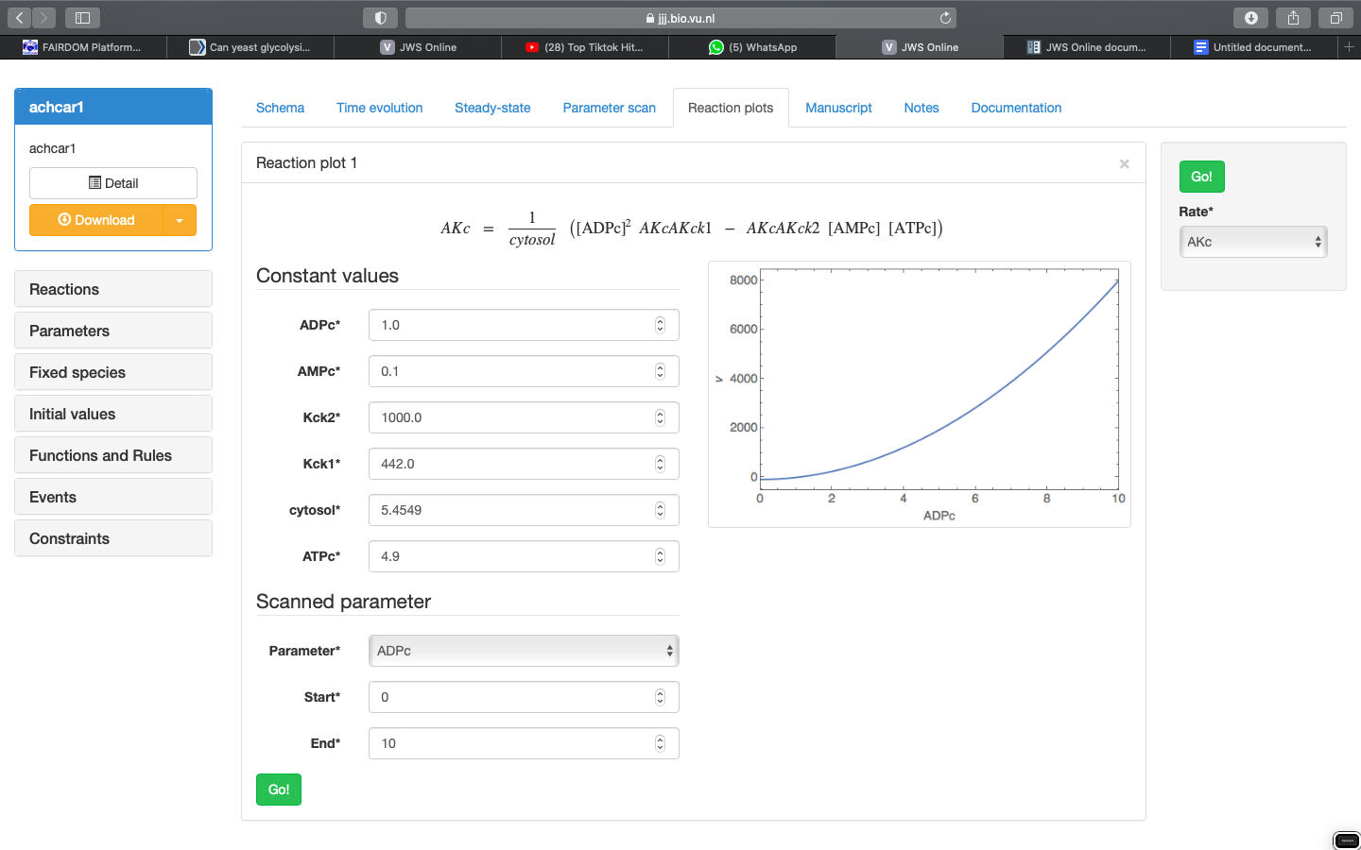

The model simulation page loads with a schematic representation of the current model. This page is where all of the available analyses are performed including:

**5.TIME EVOLUTION**

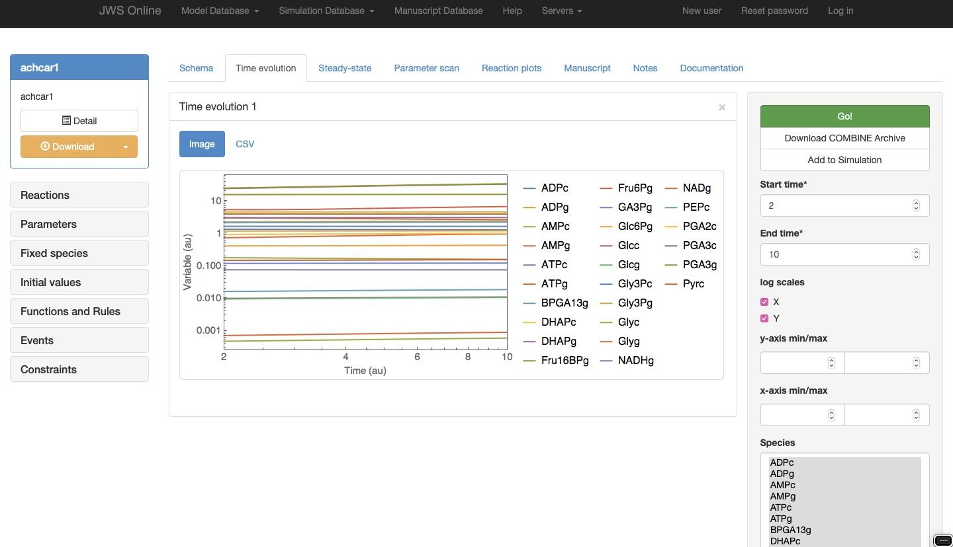**6.Steady state and Control analysis:**

Clicking on the Steady-state tab will take you to the steady-state analysis page.

Steady state: If the model is capable of achieving a steady-state flux (∂s∂t=0∂s∂t=0) this button will return the steady-state concentrations and fluxes.

Jacobian matrix: returns the matrix of all first-order partial derivatives of the system variables.

Eigenvalues: returns the eigenvalues of the Jacobian matrix

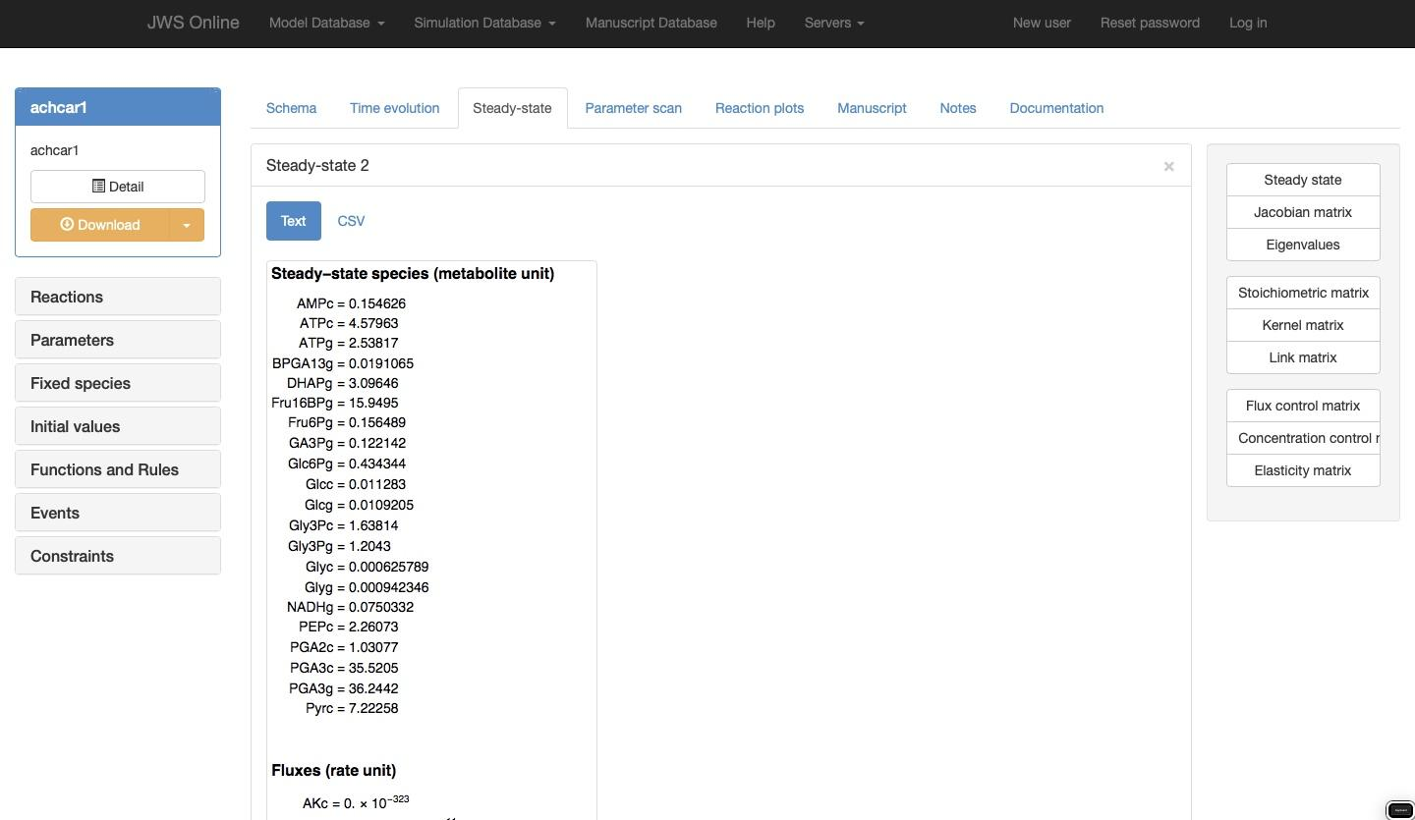

**7.PARAMETER SCAN:**

In the Parameter scan section, you are able to perform a scan of the effect of an individual model parameter on a selection of steady-state variables. In the control box on the right you will be able to specify a parameter to scan, the desired scan values (start, end, steps), and the output variables (Species, Rates, Assignment rules) to plot. Clicking ‘Go’ will perform the scan and display the results in a new result panel.

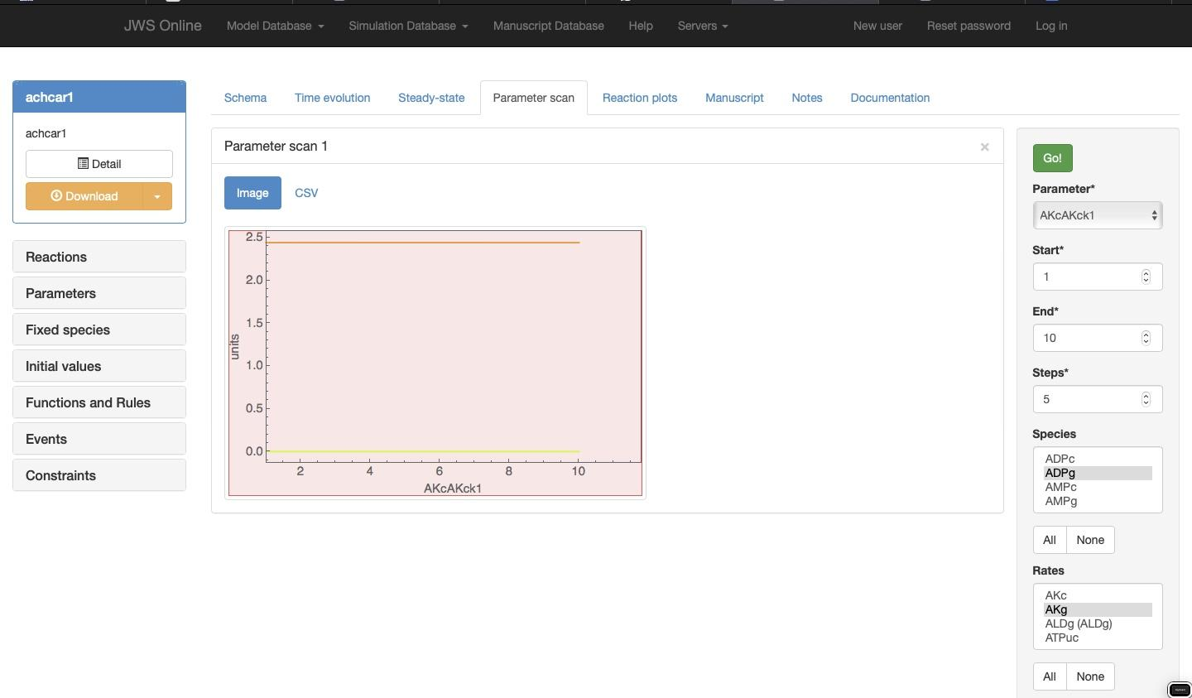**8.MANUSCRIPT**

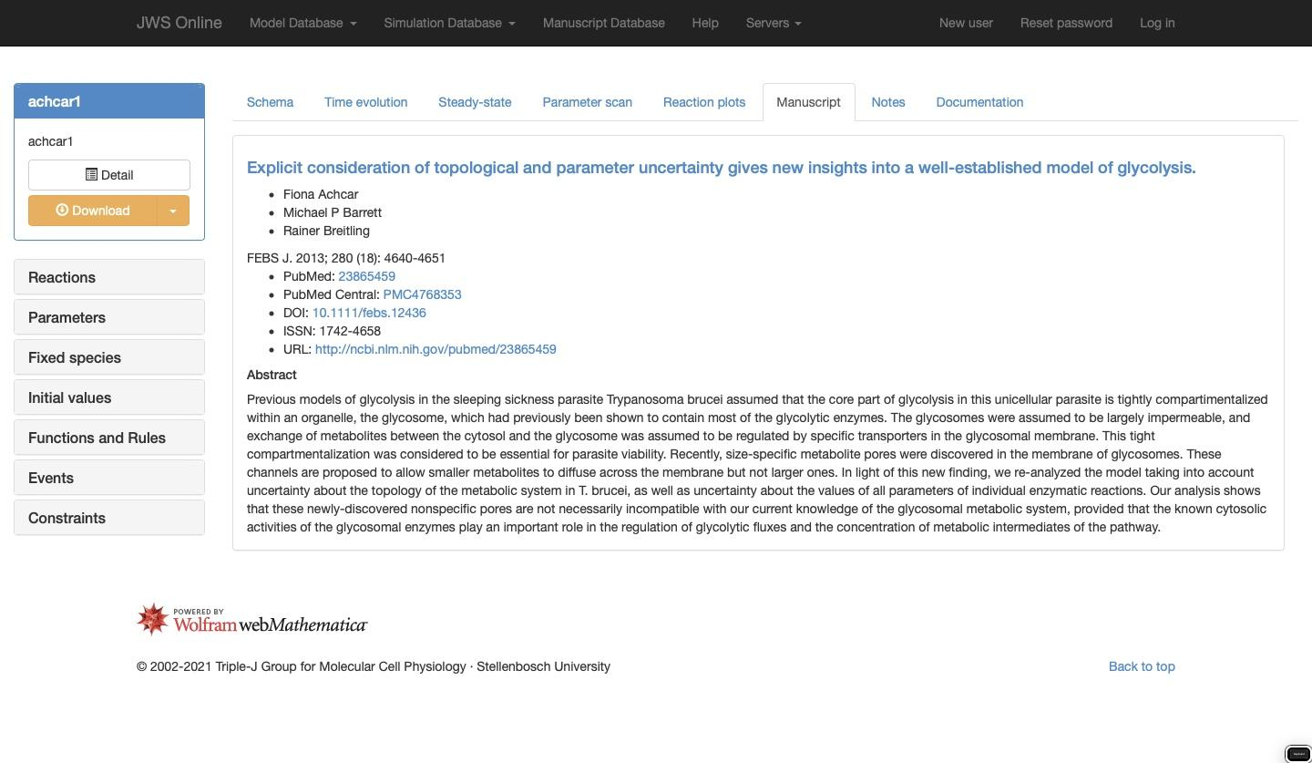

**9.DOCUMENTATION:**



